NMSIM-GIS 3D: User Guide

## Foreword

Based on the Sound Modelling Tools (SMT) user guide, this document presents a method for asset creation, asset application and result navigation of the NMSIM-GIS 3D software. The method explains the process for the installation of the application and setup of the ArcMap environment required to gather the initial files. The guide describes all inputs required to simulate a model successfully and explains the process of viewing, animating and querying the results. The area surrounding the University of Canterbury, New Zealand is used in Section 2 as the example area to gather assets for application input. The area surrounding Mt.Taranaki, New Zealand is used in the remaining sections to present a natural landscape used by the web application.

**Table of Contents**

**Foreword** **0**

**1 NMSIM-GIS 3D Setup** **2**

1.1 Download 2

1.2 Installing and running the application 2

**2 GIS Based Inputs** **3**

2.1 Elevation Data 3

2.2 Ground Cover 4

2.4 Source Locations 5

2.5 Model Extent 7

**3 Application Inputs and Asset Generation** **8**

3.1 Project Creation 8

3.2 Inputs and Variables 9

3.3 Asset Generation 10

**4 Application Simulation and Viewing** **11**

4.1 View Controls 11

4.2 Data Analysis 12

# 1 NMSIM-GIS 3D Setup

### 1.1 Download

This guide is provided as part of the github repository also containing the application code for NMSIM-GIS 3D all project files need to be downloaded and placed in a folder close to the root of your chosen drive. Additionally you will require the packed conda environment containing the osgeo, arcpy and other libraries required to run the application without error.

**GitHub Repository:** [**https://groups.google.com/forum/#!forum/soundmappingtools**](https://groups.google.com/forum/#!forum/soundmappingtools)

**OneDrive Conda Env:** [**https://ucliveac-my.sharepoint.com/:u:/g/personal/lwh34_uclive_ac_nz/EZ8R0ax1CFRLp07nhONk_0kB3yOBrd5VuW-PLYW23dHGlg?e=8udYj2**](https://ucliveac-my.sharepoint.com/:u:/g/personal/lwh34_uclive_ac_nz/EZ8R0ax1CFRLp07nhONk_0kB3yOBrd5VuW-PLYW23dHGlg?e=8udYj2)

The sms-conda.tar.gz file should be placed in the ‘flsk’ project files folder.

### 1.2 Installing and running the application

You will require:

* An install of a GIS application capable of creating shape (.shp) and raster (.tif) files.
* An installation of Conda. I used Conda version 4.13.0 to package the environment so make sure your install is compatible with this version. You will want the conda command present in your environment variables for use with command prompt, this is usually an option on initial install.
* A web browser. The application was tested within a Chromium based browser.
* The files from the links specified above.

First you will install the conda environment, navigate to the main project ‘flsk’ folder in any command line tool and run the ***setup.bat*** file. This will unpack the environment ready for use immediately.

Second, also from the ‘flsk’ folder run the ***app.bat*** command. This should launch the web application ready for use. You should see in the terminal where it is hosted i.e. <http://127.0.0.1:5000>. Navigate to this address in your web browser.

Additional launches only required the ***app.bat*** command as the conda environment would already be installed and available.

***Note:*** The console running the application may sometimes contain additional logging not provided in the import page of the application.

# 2 GIS Based Inputs

The following section contains information for asset generation using ArcMap software. You are able to use any software that can edit .tif and .shp files if you are more familiar.

### 2.1 Elevation Data

The Land Information New Zealand (LINZ) LIDAR DSM database was used to obtain the height map mosaic of the Port Hills in a TIFF format. This used the NZGD 2000 New Zealand Transverse Mercator map projection and is the projection that will be applied to all other components for the model. The data has a default resolution of 1 metre cells but is able to be scaled down to improve rendering times (discussed in Section 4). Any raster dataset that is compatible with ArcMap can be accepted as an input for the elevation model.

Import the Digital Elevation Model to your Blank Map.

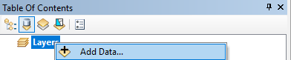

**Fig. 1.** *Option to add a selection of data to an ArcMap view.*

This can be completed either by right-clicking on the layers and selecting your DEM raster from the computer file system or you can simply drag it into the Table of Contents (ToC) via a File Explorer window.

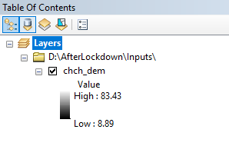

**Fig. 2.***Import of a height map DEM.*

The DEM should be on display within the Data View and if it is not aligned in your view you can right-click on the imported DEM in the ToC and select Zoom to Layer.

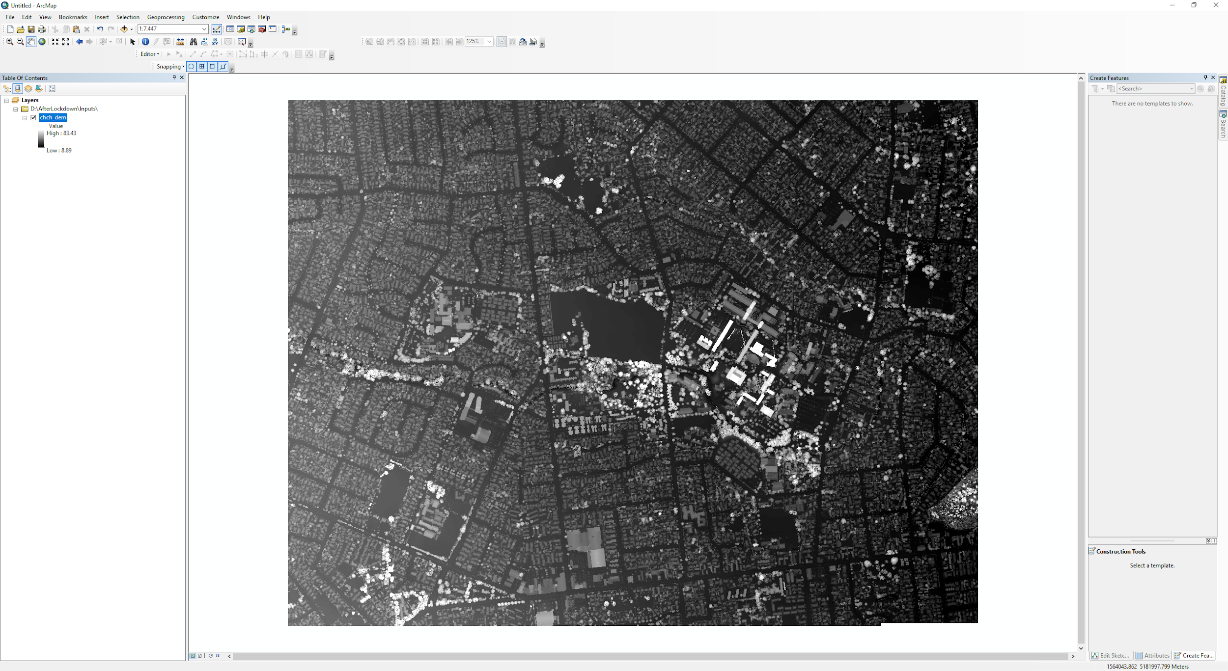

**Fig. 3.** *Imported base layer height map of the University of Canterbury, Christchurch, NZ*

### 2.2 Ground Cover

A uniform ground cover raster can be created using the Create Constant Raster (Spatial Analyst) tool. This can be configured to generate a raster with the same extent as your current DEM. Please note that this method only covers the method for creating a single value raster data set to obtain a ground cover raster. If you require multiple ground cover types you may want to look into more advanced land cover classification tools.

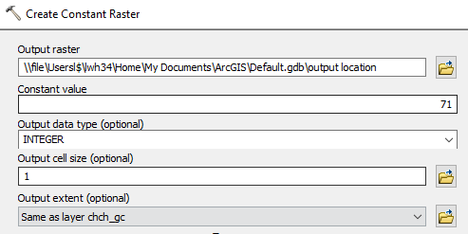

**Fig. 4.** *Example of a constant raster creation input to give the size and setup for a complete ground cover raster.*

This raster will not have an inherent coordinate system, in order to apply one before importing the raster, right-click on the raster in the ArcMap Catalog > Properties… and scroll down to edit the current coordinate system.

Use the Add Field Tool to add a NMSIMTYPE field to this new raster. Edit this new field to the land cover type that is present within your DEM from Table 1.

***Table 1:*** *Land cover classifications for NMSIMGIS. The NMSIMTYPE codes were based on the National Land Cover Data (NLCD). Table obtained from [1].*

| **Land Cover Type** | **NMSIMTYPE** | **NLCD Codes** |
| --- | --- | --- |
| Open water | WATER | 11 |
| Snow-covered landscape | SNOW | 12 |
| Developed, open space | URBAN1 | 21 |
| Developed, low intensity | URBAN2 | 22 |
| Developed, medium intensity | URBAN3 | 23 |
| Developed, high intensity | URBAN4 | 24 |
| Barren land | BARREN | 31 |
| Unconsolidated shoreline | SHORE | 32 |
| Deciduous, evergreen, or mixed forest | FOREST | 41-43 |
| Dwarf scrub or shrub/scrub | SHRUB | 51, 52 |
| Grassland/herbaceous land cover | GRASS | 71, 72, 81, 82, 95 |
| Wetlands of any type | WETLAND | ≥90 |
| Lichen-dominated landscape (Alaska) | LICHEN | 73 |
| Moss-dominated landscape (Alaska) | MOSS | 74 |
| NoData classification used in Alaska | AK | 1 |

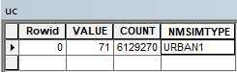

**Fig. 5.** *Example ground cover attribute table for a developed, open space area.*

### 2.4 Source Locations

A source location shape file determines where the noise source is positioned relative to the DEM raster. It will also have an attribute that states how high above ground level the source is for the simulation taking place.

To create a new source location file go to Catalog > Right-Click desired location folder > New > Shapefile…

Keep the default feature type as Point and edit the coordinate system to be the same as your DEM. The newly created shapefile should automatically be added to your current map view.

You are now able to add a point to show where your source is located for the simulation, the addition of multiple points requires a unique ID system, which is easily implemented in the attribute table. Please note that multiple points in a single shapefile will not generate separate resulting models, but a singular model with all point sources appended to create a multi-source soundscape result.

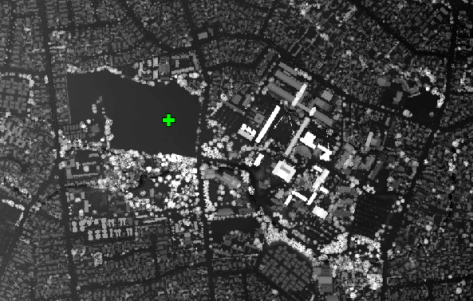

**Fig. 6.** *Example of a noise source point located within Ilam Fields, adjacent to UoC.*

You now need to add a field with the Add Field (Data Management) tool to the shapefile table with the name S_OFFSET. The value of S_OFFSET is the height in metres above the current ground level directly below the points within the shapefile.

Due to the nature of the S_OFFSET variable a consistent altitude is not guaranteed, to circumvent this use the Extract Values to Points (Spatial Analyst) tool with your point shapefile and elevation raster. This will output a new shapefile with an additional attribute table column that contains the raster data for each point; this can be used to calculate individual S_OFFSET values that will have a consistent altitude across all points.

In addition to the S_OFFSET value, additional fields are able to be added to the attribute table of the shape file corresponding to the names and values below:

***SPEED, (m/s)***

***HEAD, (degrees)***

***ROLL. (degrees)***

***PITCH, (degrees)***

***ENGINE. (%)***

***S_OFFSET, (m)***



**Fig. 7.** *An attribute table of a shapefile giving an S_OFFSET of 10 i.e. the equivalent of the noise source being located 10 metres above ground level.*

### 2.5 Model Extent

To save time in terms of the simulation render duration, you are able to have another shape file that defines the set of cells that will be used to perform model calculations. This must be equal to or less than the extent of your DEM raster.

To create one you will again create a new shapefile, this time with the Polygon feature type and matching the coordinate system of your DEM.

Create a rectangle shape to define the cells that you wish to be used in model calculations within the simulation. Make sure that it covers all points in your source position file.

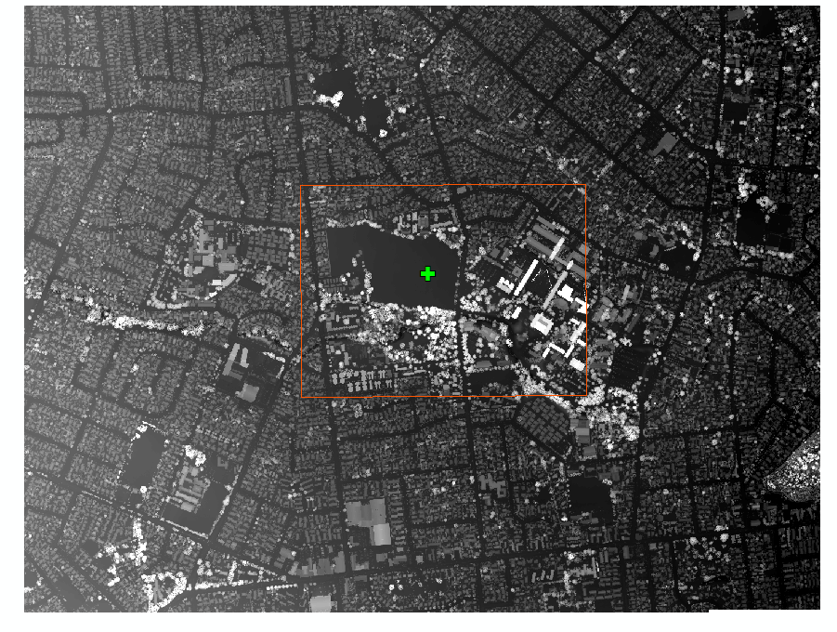

**Fig. 8.***Example of a model extent (Orange Box) only the cells within the extent of this rectangle will be used in model calculations.*

# 3 Application Inputs and Asset Generation

Once the web application has been launched you will be faced with a single button home page. To start the modelling process click the button, you will be moved to the first Create Project page.

### 3.1 Project Creation

Once in the project creation page you will want to use the first section on the left hand side of the page (Figure 9). In the create project field you will input your chosen name and click the ‘Make’ button. This will create a local folder with that name and will also show up in the choose project list.

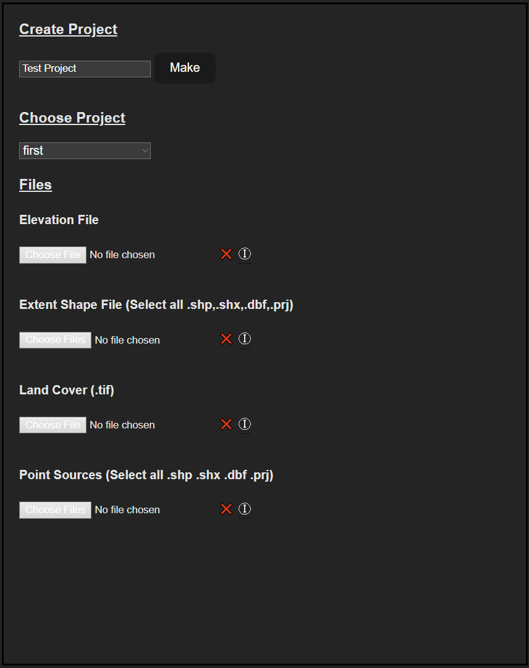

***Figure 9 - Create and choose a project. Upload initial assets..***

You can then upload the files created in the process of Section 2. Make sure you upload all sub files as well shown inside the brackets at each option. These files contain metadata important to the modelling process.

### 3.2 Inputs and Variables

The next stage of the modelling process is selecting your variable weather conditions, the output noise weighting and the sound source type.

These fields are pretty self-explanatory and will apply to the entire modelled environment when simulating the sound propagation. If you have your own custom noise source files for an additional vehicle not provided with the application these can be added to the project files at ‘***.\flsk\static\resources\sound_source’*** you may add new folders here for different categories the application will acknowledge these on page refresh.

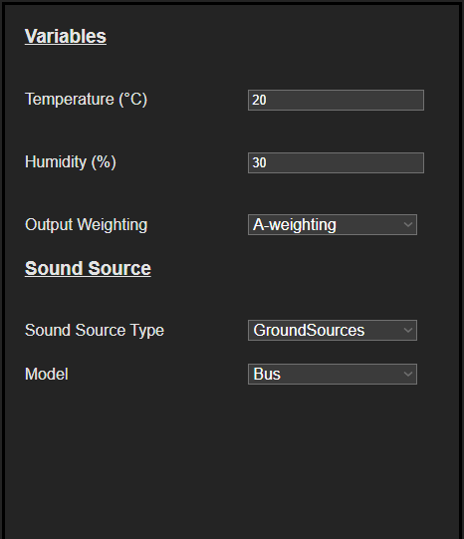

***Figure 10 - Variable fields and noise source selection.***

### 3.3 Asset Generation

Finally the controls section, below are points explaining what each control does (Figure 12).

* **Import Files -** This will import the files uploaded in section 3.1 these will be copied to the project folder and readily available if you relaunch the application or have to switch between projects.
* **Simulate Sound Propagation -** This will begin the process of simulating the sound propagation. Warning: This can take a long time based on your model extent (2.5) and number of points along flight path (2.4).
* **Satellite and Propagation Images -** This will access the MapBox API, get the satellite imagery for your model and trim it to size. Additionally it will take the sound propagation rasters from your model simulation and convert them to images for overlaying in the viewing process.
* **Make 3D Mesh -** This will convert your elevation data raster files into a 3D model ready for viewing with Three.js.
* **To Viewer -** This simply takes you to the viewing page and will display data relating the currently selected project.

You will need to create a MapBox account and generate an API token to use the satellite imagery control. As of January 2023 it is free to use for up to 50,000 requests per month.

After which you will need to enter these details into the script file detailed in Figure 11.

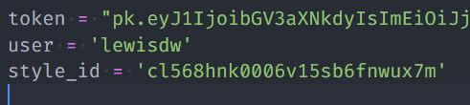

***Figure 11 - MapBox settings in ’.\flsk\py_scripts\map_image_from_extent.py’ found on lines 10-12.***

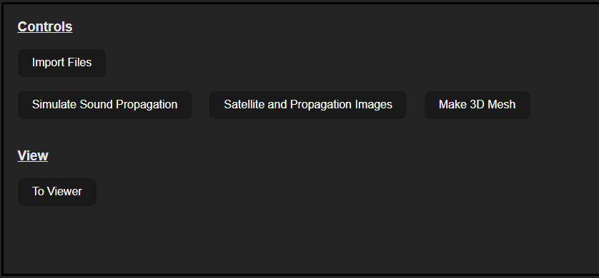

***Figure 12 - Controls section for file upload and asset generation***

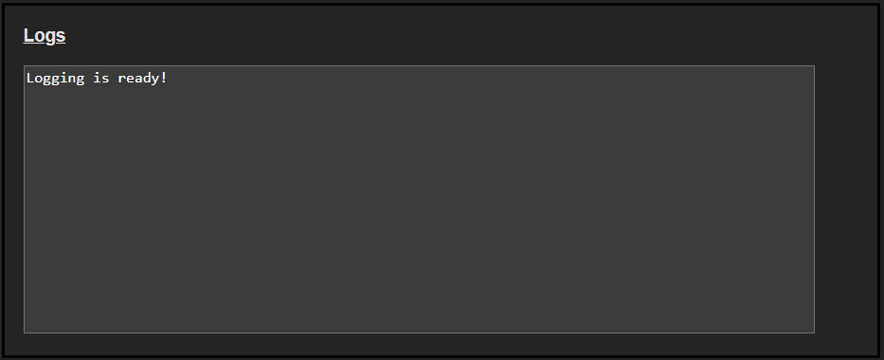

***Figure 13 - Logging section for information regarding all activities within the create and import page of the application.***

# 4 Application Simulation and Viewing

Once in the viewing page your selected project should load up the model with image overlay. Additionally the first propagation image should be shown overlaid on top of the 3D model.

### 4.1 View Controls

Now that you are in the viewing page and the assets have loaded you are able to move the camera to zoom, pan and rotate the camera in order to get to any point of interest within your model

### 4.2 Data Analysis

Below are points explaining what each control does (Figure 14).

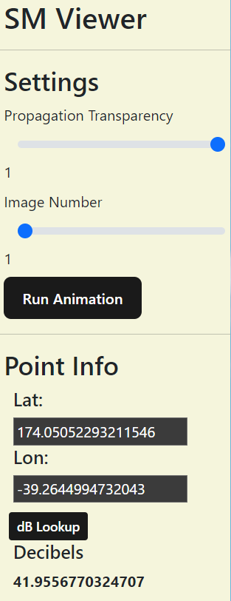

***Figure 14 - Viewing page controls and information section.***

* **Propagation Transparency -** This slider will alter the transparency of the propagation overlay. This will allow the user to identify specific underlying features on the terrain.
* **Image Number -** This slider refers to the progression of noise source points as detailed in the original shape file.
* **Run Animation -** This button will run an animation of all propagation images changing consecutively once every second. Click the button again to stop the animation.
* **Lat and Lon:** These entry fields are populated any time the user clicks on the 3D model. It will extract the mouse position and reference against the model to get the coordinates of the clicked position. If this is also on top of the propagation image it will produce the observed decibel level at that position.
* **dB Lookup:** The latitude and longitude fields can also be manually entered and this button will look up the observed decibel level of the observed point.

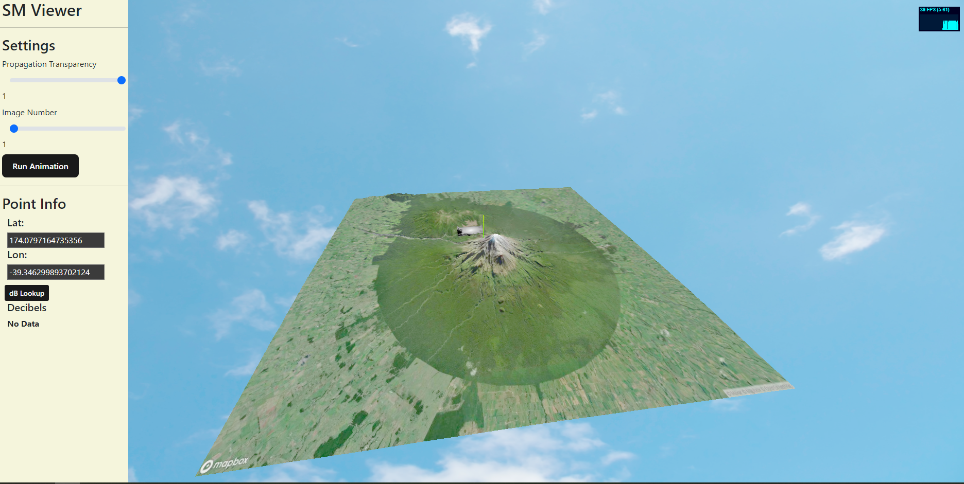

***Figure 15 - Full viewing page with model and propagation image overlay.***